Names: Uwera Delhi Adeline

ID: 22791

**Web Technology Final Project**

**Topic of My Project:** Online Chicken Ordering Management System

As we, all know Rwanda is a developing country that is developed quickly, by using technology in almost activities. They play an important role in development by offering online services and in communication.

My project is about **Online Chicken Ordering** for customers and it manages all orders of the company. The company got problem of their customers of getting way of ordering easy so a new system was developed, which will simplify the work for those who needs chicken quickly also help the company to make more customers and earn profit and it will make the increase their speed of working.

**PROBLEM STATEMENT**

* Customer had problems of time spent going to the Farm to buy chickens
* Management of customer orders
* It was not easy to get clients
* Management of chicken bought and sold

**GENERAL OBJECTIVE**

The general objectives of the study are to design a system that will manage the chicken ordering

**SPECIFIC OBJECTIVE**

* To facilitate the management of orders
* Remove the manual recording of information
* Help in the advertisement of the company’s activities
* Facilitate Farmers easily know where to get chickens.

**IMPLEMENTATION OF NEW SYSTEM**

**Login Form**

The login form helps the user to get access of the system after entering all needed information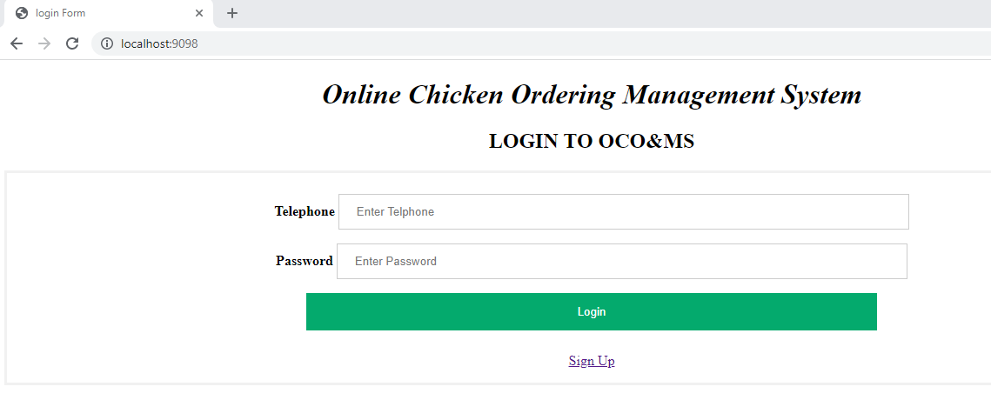

**Registration Form**

This form is where users are added in order to have access to the system

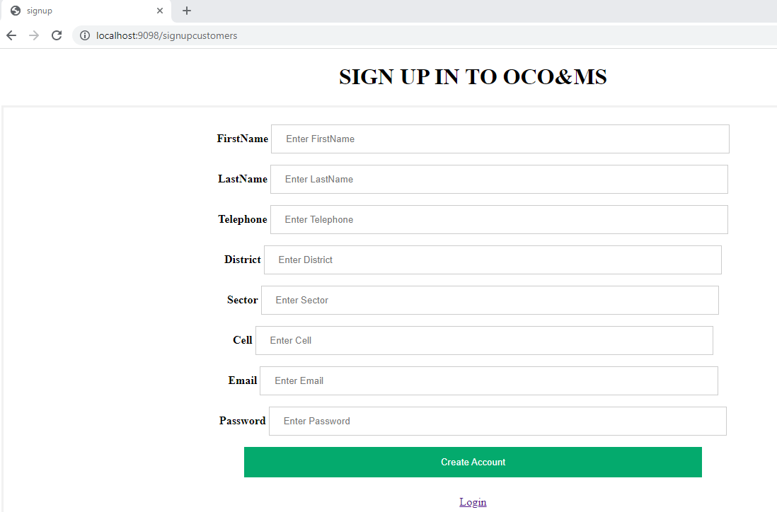

**Add Chickens Form**

Seller uses this form to register chickens

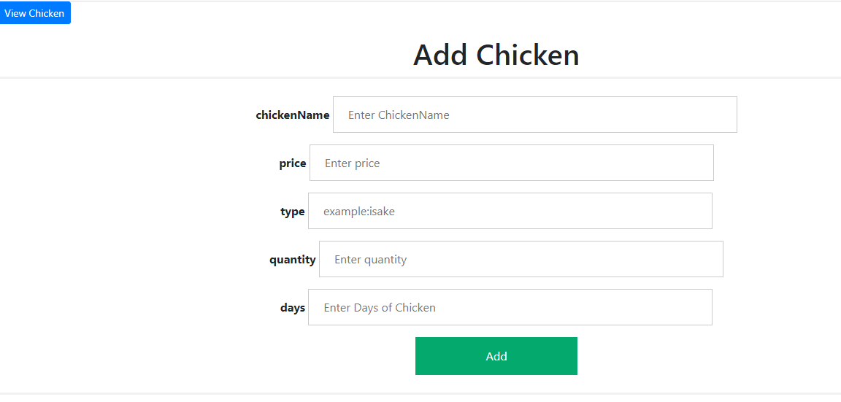

**Ordered Chickens List**

This gives information about ordered chickens

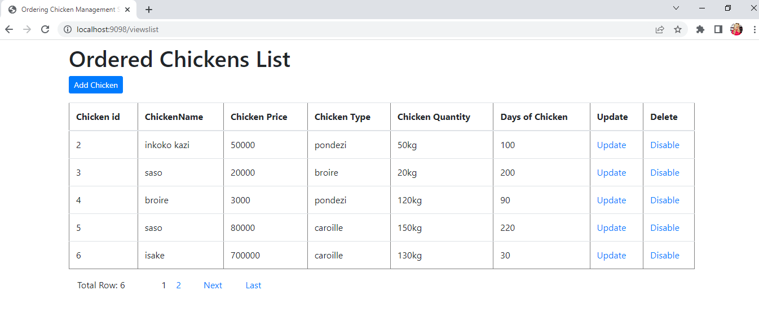

**When you need To Update**

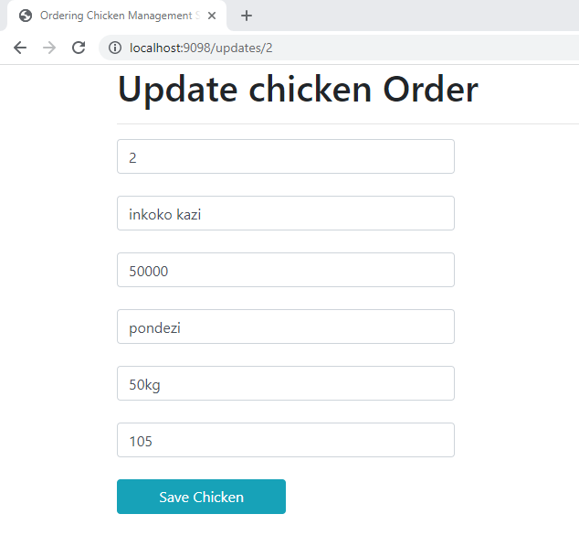

**Customers Chickens Orders in Database**

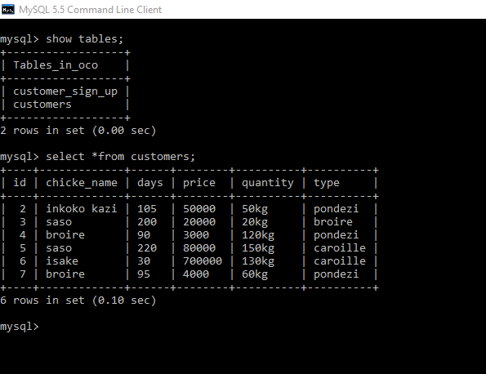

**As conclusion** is thatthe objective I have assigned myself have been achieved where research problem solved